Algebra 2
Notes 6.1: Solving Cube Root Equations

Let us recall what we know about Square Roots:

$\sqrt{64}$ $\sqrt{1}$ $\sqrt{x^{2}}$ $\sqrt{-100}$

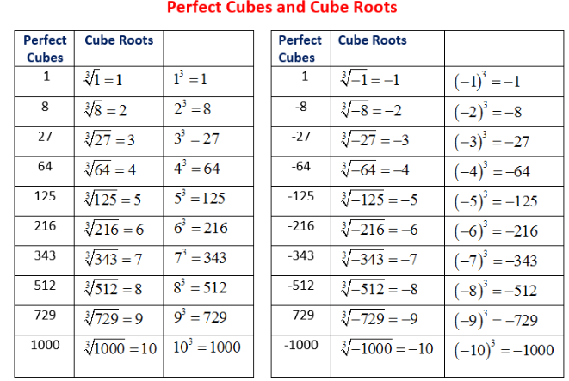
A ________________________ of a number is a value that, when multiplied by itself __________________ times (Cubed), equals the original number, essentially reversing the “cubing” operation.

Examples: Find the cube roots of the following:

$\sqrt[3]{64}$ $\sqrt[3]{1}$ $\sqrt[3]{x^{3}}$

$\sqrt[3]{-216}$ $\sqrt[3]{8}$ $\sqrt[3]{-27}$

$\sqrt[3]{-343}$ $\sqrt[3]{-\frac{27}{1000}}$ $\sqrt[3]{125}$
Solving Cube Root Equations
*Notice that you can take the cube root of a negative and still get a real answer.
This means we don’t need to check the answers when we solve cube root equations!

Radical Form Exponential Form
$\sqrt[3]{x}$ same as $x^{\frac{1}{3}}$

Steps for solving:
1. Isolate the radical (if possible)
2. Raise both sides to the power of the index (in this case, cube both sides)
3. Solve for x

For each example, solve for x.
1. $\sqrt[3]{x}=4$ 2. $\sqrt[3]{x}=-2$ 3. $\sqrt[3]{5x-1}=4$

4. $\sqrt[3]{2x+3}=2$ 5.${\left(x+4\right)}^{\frac{1}{3}}-3=-5$ 6. $3\sqrt[3]{2x+1}-4=8$

7. $2{\left(x+6\right)}^{\frac{1}{3}}-2=3$ 8. $\sqrt[3]{x-7}=2\sqrt[3]{3x+2}$ 9. $3\sqrt[3]{x-3}={\left(2x-1\right)}^{\frac{1}{3}}$

10. ${\left(3x^{3}+3x^{2}-4x\right)}^{\frac{1}{3}}=\sqrt[3]{-x^{2}+x}$

11. ${\left(2x^{3}-3x^{2}-5x\right)}^{\frac{1}{3}}=\sqrt[3]{x^{2}-x}$

Applications
1. A team of aerospace engineers is designing a new type of communication satellite. The mass (M) of the core payload, in kilograms (kg), is directly related to the required diameter (D) of the main power generator, in meters (m). This relationship is crucial for ensuring the satellite can be successfully launched and powered.
The governing equation developed by the engineers is $\sqrt[3]{D}=0.05M-0.2$
If the mission requires a core payload mass (M) of 12 kilograms, what must the diameter (D) of the main power generator be in meters? Round to the nearest tenth of a meter.

2. The minimum time (T), in hours, required for a specialized concrete mixture to cure (harden) is related to the maximum stress load (L), in tons per square meter $\left(\frac{t}{m^{2}}\right)$, it must withstand. The relationship is given by the formula: $\sqrt[3]{T}=0.5L+1.2$

If a beam must withstand a maximum stress load (L) of 10 $\frac{t}{m^{2}}$ , what is the minimum required curing time (T) in hours? Round your answer to the nearest whole hour.

3. Kepler's Third Law relates the orbital period (P) of a small body (like a moon or satellite) and the semi-major axis (a) of its orbit around a massive object. A simplified model for a small moon orbiting a newly discovered planet is: $\sqrt[3]{a}=0.2P$, where P is the orbital period in Earth days and a is the semi-major axis in ${10}^{5}$ kilometers.
If the orbital period (P) of the moon is 8 Earth days, what is the semi-major axis (a) of its orbit in ${10}^{5}$ kilometers?

4.The time (t), in minutes, required for a certain chemical reaction to reach 90% completion is related to the concentration (C), in moles per liter, of the catalyst used. The empirical relationship is: $\sqrt[3]{t}=10-5C$
If the reaction uses a catalyst concentration (C) of 1.8 M, how many minutes (t) will it take for the reaction to reach 90% completion?

